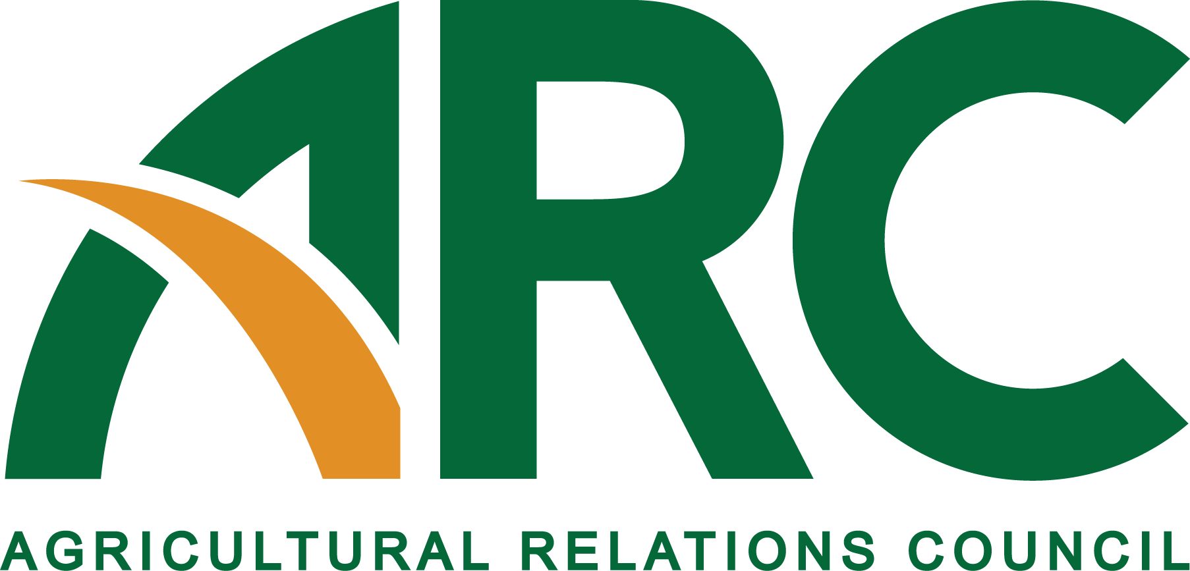

**2017 ARC Foundation Marketing Intern Host Application**

The ARC Foundation is instituting an internship program beginning in the summer of 2017. Under this unique arrangement, ARC will partner with an ARC-member organization to coordinate the internship program. Key details:

* Intern will be hosted by the ARC-member organization.
* Internship will be worth $5,000 -- $3,000 to be underwritten by Gardner & Gardner Communications through the foundation; $2,000 to be funded by the hosting organization through the foundation.
* $1,000 of the total $5,000 will be used for the intern to attend the annual professional development meeting of ARC – to be held June 20 through 22 in Sacramento, California
* The intern will spend 80% of his/her time on host organization projects and 20% to support and attend the ARC annual meeting.
* The internship will be 10-12 weeks long.
* The host organization will be chosen by Dec. 31, 2016.
* Student applications will open Feb. 1, 2017, and be selected in April.
* Intern will be chosen by a representative of the host organization, along with a representative of Gardner & Gardner Communications and one board representative. These people will be part of a Futures Committee within ARC.

**Organization Name:**

**Organization Address:**

**Location intern will be working (if different from above):**

**Contact Person:**

**Email:**

**Phone:**

**Name of ARC Member(s) in your organization (You must have an ARC member on staff to apply for this opportunity.):**

**Description of your organization:**

**Responsibilities/experiences/projects the intern will likely be involved with:**

**Skills required or desired:**

**Why do you believe this internship will be a good opportunity for your organization as well as the ARC intern?**

**What is your organization’s philosophy regarding public relations and the internship experience?**

**___________________________**

**All applicants will be notified of the outcome shortly after the selection process is complete.**

**Please send the completed application by email by Monday, Dec. 12, 2016, to:**

**Kristy Mach, Associate Executive Director**

**Ag Relations Council (ARC)**

**605 Columbus Ave South**

**New Prague, MN 56071**

**952/758-5811 (Gardner & Gardner Communications, acting on behalf of ARC)**

**arc@gandgcomm.com**